**THE SIX BANDERS**

|  |
| --- |
|  |
| Castle Maze |
| [Find the Exit] |
| Version #1.0  All work Copyright © 2012 by The Six Banders.  All rights reserved. |
|  |

**TABLE OF CONTENTS**

**Version History** **3**

**Game Overview** **4**

**Game Play Mechanics** **4**

**Camera** **4**

**Controls** **4**

**Interface/Level Design** **4**

**Menu and Screen Descriptions** **5**

**Game World** **6**

**Levels** **6**

**Game Progression** **6**

**Enemies** **6**

**Weapons** **6**

**Abilities** **6**

**Scoring** **7**

**Assets** **7**

**Sound Index** **7**

**Story Index** **7**

**Future Features** **8**

# Version History

Version 1.0 ---------------------------------------------------------------- The working game with 1 level

# Game Overview

*The purpose of this game is to entertain the player by providing a different play environment. All the escaping puzzle games are built for improving the player think ability. Our game motivates the player to play as the game is not only an escaping part, but it has enemies which stop the player from escaping.*

# Game Play Mechanics

*This game uses a 3D platform as walk surface for the player and enemies will be behind the player stopping player not to escape from the castle. The score is calculated based on the enemies killed and the time completed.*

# Camera

*This game uses the third person shooter for player and a top view camera for the mini map.*

# Controls

*This game uses standard controls WSAD for the player movement and the mouse to look all over the play scene.*

*The controls will be as follows:*

*WSAD – Player front, back, right, left movement*

*Mouse - To look around*

*Left Click - To Fire*

*Right Click - To Aim*

*Space - Jump*

# Interface/Level Design

*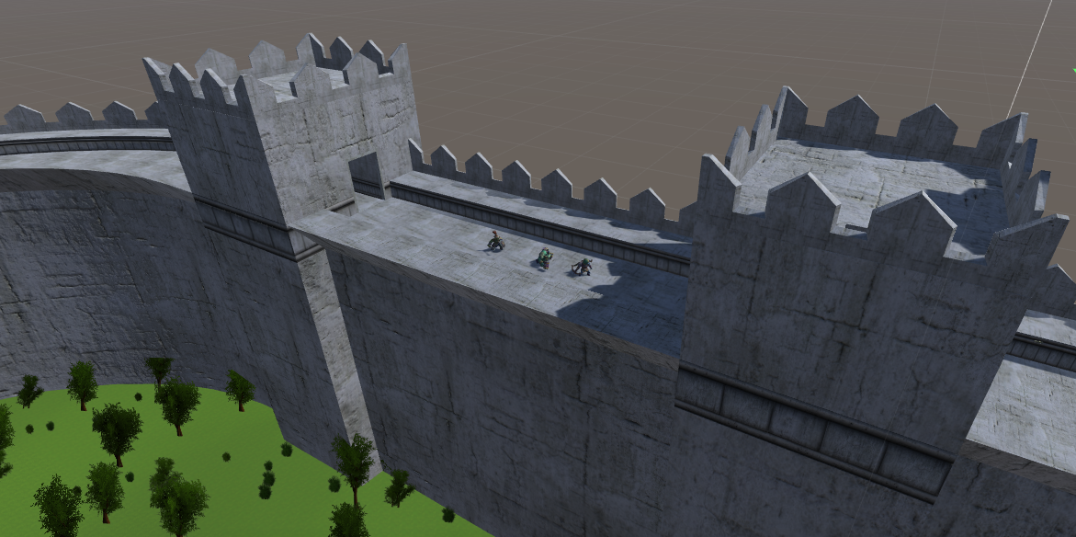  
Level 1 - Game Scene Shot 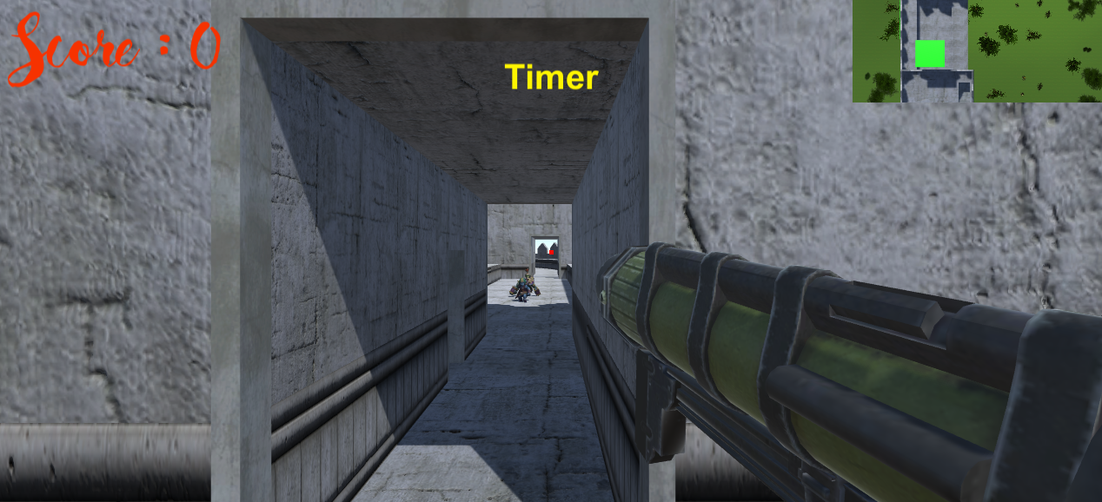  
Level 1 - Game Play Shot*

# Menu and Screen Descriptions

* *The game starts with the start screen containing a start button.*
* *The first scene is level 1, which is on a castle walls.*
* *The second scene is level 2, where the enemies will chase player.*
* *The third scene is level 3, where the player is in a garden need to escape from the enemies.*
* *The game ends with end screen which has a button leads to the start screen.*

# Game World

*The game environment is in a castle. The first level is on the walls of the castle and the second level is in the castle and the third level is in the garden which is the final level.*

# Levels

* *The level 1, which is on a castle walls.*
* *The level 2, where the enemies will chase player.*
* *The level 3, where the player is in a garden need to escape from the enemies.*

# Game Progression

*The game progress is based on the player finding exit to the next level.*

# Enemies

*The enemies are from another kingdom want to kill player before leaving the castle. Enemies are Orc Ranger, Orc Soldier and Orc Tanker with their own Melee attacks on reaching to the player.*

# Weapons

*The player has a Rocket launcher which is used to fire at the enemies. Enemies have their own weapons to attack the player. Enemies have sword, arrow and hammer to attack the player.*

# Abilities

*The player has the ability to shoot the enemies and track the enemy movement by using the mini map.*

# Scoring

*The score is calculated based on the enemies killed. For each enemy killed the player receive 10 points.*

# Assets

|  |  |  |
| --- | --- | --- |
| *Orc Ranger (Yellow)* | *Orc Ranger (Green)* | *Orc Ranger (Red)* |
| *Orc Ranger (Blue)* | *Orc Tanker* | *Orc Soldier* |

# Sound Index

*The game uses a start-up music and shooting sound and enemy blast sound and walk and jump sounds.*

# Story Index

*The player is a castle owner, some enemies attack the castle and kills everyone and the player arrange a bomb to blast the castle with the enemies and need to escape from the castle before the time runs out.*

# Future Features

* *The Boss enemy*
* *The story*
* *Animations*
* *Physics*